Newsletter
10th June 2019
Dear Parents/Carers

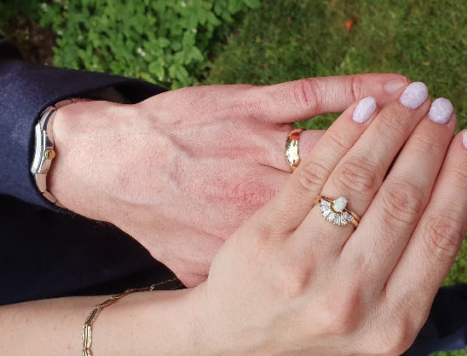
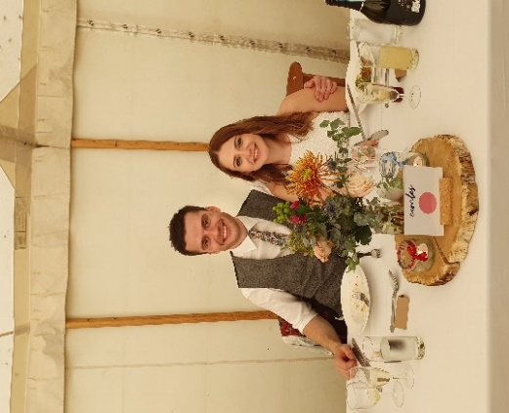
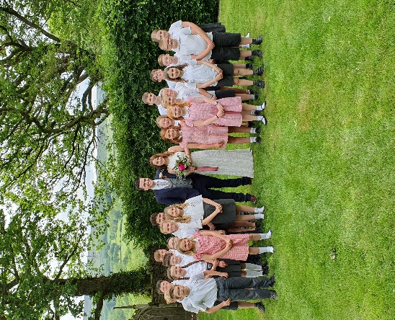

These gorgeous photographs simply say it all; as on Saturday 1st June Mr and Mrs James celebrated their wedding day: the sun shone, the rain stayed away and a wonderful time was had by all!

The Class 3 choir’s performance (complete with brightly coloured kazoos) was greatly appreciated by the wedding party; and our thanks go to Mrs Emma Prince and Mrs Saffron Baker for accompanying the children, so that those of us from school who were invited as wedding guests to this very special day could truly relax and enjoy such a beautiful wedding service.

Heather Stelling
Headteacher

Village Wells Dressing – Re-cycled plastic; 3D Animal Models
‘If we don’t act quickly, all animals (not just endangered species) will become extinct, including our pets, cows, sheep, hens, sparrows and everything else we take for granted’. So, how do you fancy helping your child to make a 3D model out of re-cycled plastic (of any animal/species) to feature in one of the main wells dressings in the village (please note, not the school one); to help spread this message?

Your child’s plastic replica can be made in any way they like (mainly from re-cycled plastic) to set into the bare clay; but it should be no bigger than 12cm/5” in diameter; and it will need to be in school by this Thursday 20th June. If they arrive later than this date, we cannot guarantee they will be featured in the final design.

School Wells Dressing – Flowers
This year we’ve designed our well’s dressing on our Woodland Learning experiences, titled ‘Wood Wide Web’; and we’re delighted to have Amy Bingham leading us in this project.

The children have all designed their personal interpretations on this theme and Amy has pulled all these ideas together to create our 2019 ‘collaborative design’. We’d really appreciate your support in providing the necessary materials for our well’s dressing (i.e. mainly flowers) so please ‘watch out’ for a text and/or letter to be sent out tomorrow.
Year 4 and Year 5 Activity Morning at S.Anselm’s
Please can your child/children arrive in school promptly tomorrow for 8.50am so that they can change into their PE kit before going on the coach (at 9.00am) for their activity morning at S.Anselm’s.

S.Anselm’s have asked that all children bring a clean pair of trainers to the event, for their sporting events on the astro-turf/or in the sports hall. They will be provided with a snack and drinks throughout the morning.

If you haven’t already signed the consent form, please can you pop into the office as soon as possible; and to cover the cost of coach transport, we would be very grateful of a voluntary, parental contribution of £4 per child.

Sports Day – Fingers crossed for Wednesday!
We’re watching the weather reports very closely … so please check for text messages in case we have to go for our reserve date (Thursday 20th June) but, whatever day, please bring your chosen seating with you.

Year 5 ‘Greenaway Day’ at Lady Manners School (LMS) – Friday 21st June
This Friday, we will be joining other LMS Cluster schools to judge a series of books that are up for this years ‘Greenaway Award’*(see note below). The children have enjoyed reading these books over the past few weeks.

Please can you pop into the office to sign a consent form; and to cover the cost of coach transport, we would be very grateful of a voluntary, parental contribution of £4 per child.

NOTE*: The Kate Greenaway Medal (i.e. the ‘Greenaway Award’) is awarded every year to a book of artistic quality. Firstly, in mixed-school groups, the children will discuss the merits of this year’s book selection through a variety of different activities and finally they will vote for a winning entry.

Serving Our Community – Community Orchard and Litter Picking
Last Thursday afternoon we braved the wet weather to serve and help our community through 2 activities, which the children thoroughly enjoyed. We joined volunteers from the Community Land Trust to weed and generally tidy-up the Community Orchard and we went litter picking around the playing fields, tennis courts, play area and bike trail.

PE Teacher
Having celebrated being judged as a ‘Good’ school by Ofsted (February 2019) we’re now thinking more
creatively to ensure we’re giving our children the best ‘all round’ education we can provide.

One of our new initiatives for 2019 – 2020 is to have a PE teacher to work alongside Mrs Trainor; and we’re delighted to share we’re welcoming an outstanding practitioner, Miss Lyn Tonks, to join our staff team from September 2019.

Our sporting trophy cabinets are already overflowing and as the children keep telling me “Mrs Stelling, you
need to buy us some more trophy cabinets”; with these two ladies ‘in charge’, I’ve got a feeling that
‘things are only going to get better’!

Farm to Plate – Exhibition and competition
Miss Eaton and Ms Kitchener are finalising our school design entry for the ‘Farm to Plate’ competition; to
Celebrate the 200th Anniversary of the Bakewell Agricultural and Horticultural Society at Bakewell Showground:
final details to follow very soon …
End of Year Show - A Midsummer Night’s Dream
This year we’re making life simpler; we’re performing our two shows on the same day in the Village Hall: a matinee starting at 2.00pm and a 6.30pm evening performance on Thursday 11th July. Details of ticket prices (to cover the cost of hiring the Village Hall for rehearsals and the performances) will follow shortly, along with drop-off and pick-up times.

Last Weeks for After-school Clubs This Term
Monday 15th July – Church Bell Ringing Club with Lisa and Amy Bingham
Tuesday 25th June– Junior Rounders (Years 3, 4, 5 and 6) with Ms Kitchener and Mrs Trainor
Wednesday 26th June – Year 1/Year 2 Cricket with RuggerEds
Thursday 27th June – Year 1 to Year 6 Maypole Dancing with Mrs Trainor and Miss Eaton

Christian Aid
Thank you for joining us in supporting the international charity Christian Aid (during a week of special
activities organised by our School Council and Ms. Kitchener) in raising £69.81.

The activities were all themed on changing lives over ‘breakfast’, including sharing a pancake breakfast, and
in doing so, helping mums and babies in the African country of Sierra Leone; in helping train nurses and build health clinics in the most dangerous place in the world to ensure they have the best medical care possible.

Dates for your diary
Mon – 17th – Fri 21st June | Well dressing in school
Monday 17th June | Class 3 RSE presentation to parents; 3.45pm – 4.15pm
Tuesday 18th June | Year 4 and Year 5 Activity Morning at S.Anselm’s, Bakewell
 | New Reception transition visit 1; 9.30am – 11.45am
Wednesday 19th June | Sports Day (on the playing fields)
Thursday 20th June | Reserved Sports Day
Friday 21st June | 3.00pm blessing of our school well’s dressing, led by Rev. Louise Petheram; all welcome to join us
Saturday 22nd June | 2.30pm Wells Dressing Blessing
Monday 24th June | Year 6 Transition Day at LMS
 | New starters in school 9.30am – 1.00pm
Tuesday 25th June | Whole school ‘Wells Dressings’ walk-around the village (weather permitting)
Sunday 30th June | Farm to Plate display/competition (details to follow)
Monday 1st July | 2pm onwards; YASSA cream tea afternoon: with a performances from our maypole dancing troop
Wednesday 3rd July | Year 6 Intake Day at LMS
 | ‘Move-up’ Day (all children, including new starters, in their new classes with new teachers)
Tuesday 9th July | Year 6 Literacy Quiz at LMS
 | Year 6 SATs results released
Thursday 11th July | ‘A Midsummer Night’s Dream’ performances, in the Village Hall:
 | 2pm Matinee and 6.30pm evening performance
Friday 12th July | End of year reports out to parents
Thursday 18th July | Whole school trip to Yorkshire Sculpture Park
Friday 19th July | Leavers Service in Church 2.00pm
 | BREAK UP FOR SUMMER HOLIDAYS
Wednesday 4th September | SCHOOL RE-OPENS FOR AUTUMN TERM

Years 4 and 5 Activity Morning to S.Anselm’s Tuesday 18th June 2019

My child/children …………………………………………………………… will be attending the Activity Morning at
S.Anselm’s on Tuesday 18th June.

Signed: …………………………………………. Name: ………………………………………. Date: ……………………………………….

--------------------------------------------------------------------------------------------------------------------------

