
Maths
Calculation
Policy

2018

Document Control
Owner
The owner of this document is the Headteacher. All requests for change should be directed to them. Any printed copies of this document are for reference only; the definitive version is the computer file held on the school office administrator’s computer.

Revision history
Version | Date | Changes | Author(s)
1 | 27/11/18 |  | KK

Approval
Version | Date | Approver(s) | Minute number
1 | January 2019 | Full Governing Body | (t.b.c)

Review period This policy will be reviewed every two years.
Version
September 2021

Objectives of this Policy.

This policy outlines both the mental and written methods that should be taught from Year 1 to Year 6. It has been written according to the National Curriculum 2014 and the written calculations for all four operations are as outlined on the appendices of the Programme of Study. (Supported by White Rose)

The document builds on the interconnectedness of mathematics and outlines the progression for addition, subtraction, multiplication and division. It is our intention that addition and subtraction should be taught at the same time to ensure children are able to see the clear links between the operations and the inverse nature of them along with multiplication and division.

Children should secure mental strategies. They are taught the strategy of counting forwards and backwards in ones and tens first before further strategies are introduced. Children are taught to look carefully at the calculation and decide, which strategy they should use. Children should explain and reason as to why they have chosen a strategy and whether it is the most efficient.
The formal written methods should be introduced when appropriate and place value is secure. Calculations that require a written method should be presented to the children and models and images, such as dienes apparatus, place value counters, etc. should be used to ensure children have a conceptual understanding of the written method and that it is not a process that the children use for every type of calculation regardless of whether it can be completed mentally or mentally with jotting i.e. the number line.

Outlines of this Policy

The policy outlines the mental strategies that children should be encouraged to use:

A mental strategy that they can always rely on E.g. counting in tens and ones, forwards and backwards E.g. 56 – 25 (count back in 10s 56, 46, 36 and back in ones 36, 35, 34, 33, 32, 31)

A special strategy they can select from a small range of strategies if they can see something special about the numbers they are being asked to calculate with E.g. 46

– 24 (I can use near doubles to support my calculation E.g. 46 – 23 – 1)
The policy outlines the written methods as suggested on the appendices of the Curriculum 2014 and suggests that children:
- Look at a calculation and decide whether it can be done mentally, mentally with a jotting or whether it needs a written method.
- Should always be shown written methods with place value apparatus to ensure children are clear about the value of the numbers that they are calculating with and the numbers do not just become digits.
- Estimate, calculate and check to ensure that the answer they generate has some meaning.

For the purpose of developing understanding there may be occasions when examples that can be completed mentally may be shown as a written method purely to develop understanding of the method. This needs to be made very clear to children and when they are practising the methods, appropriate calculations should be used.

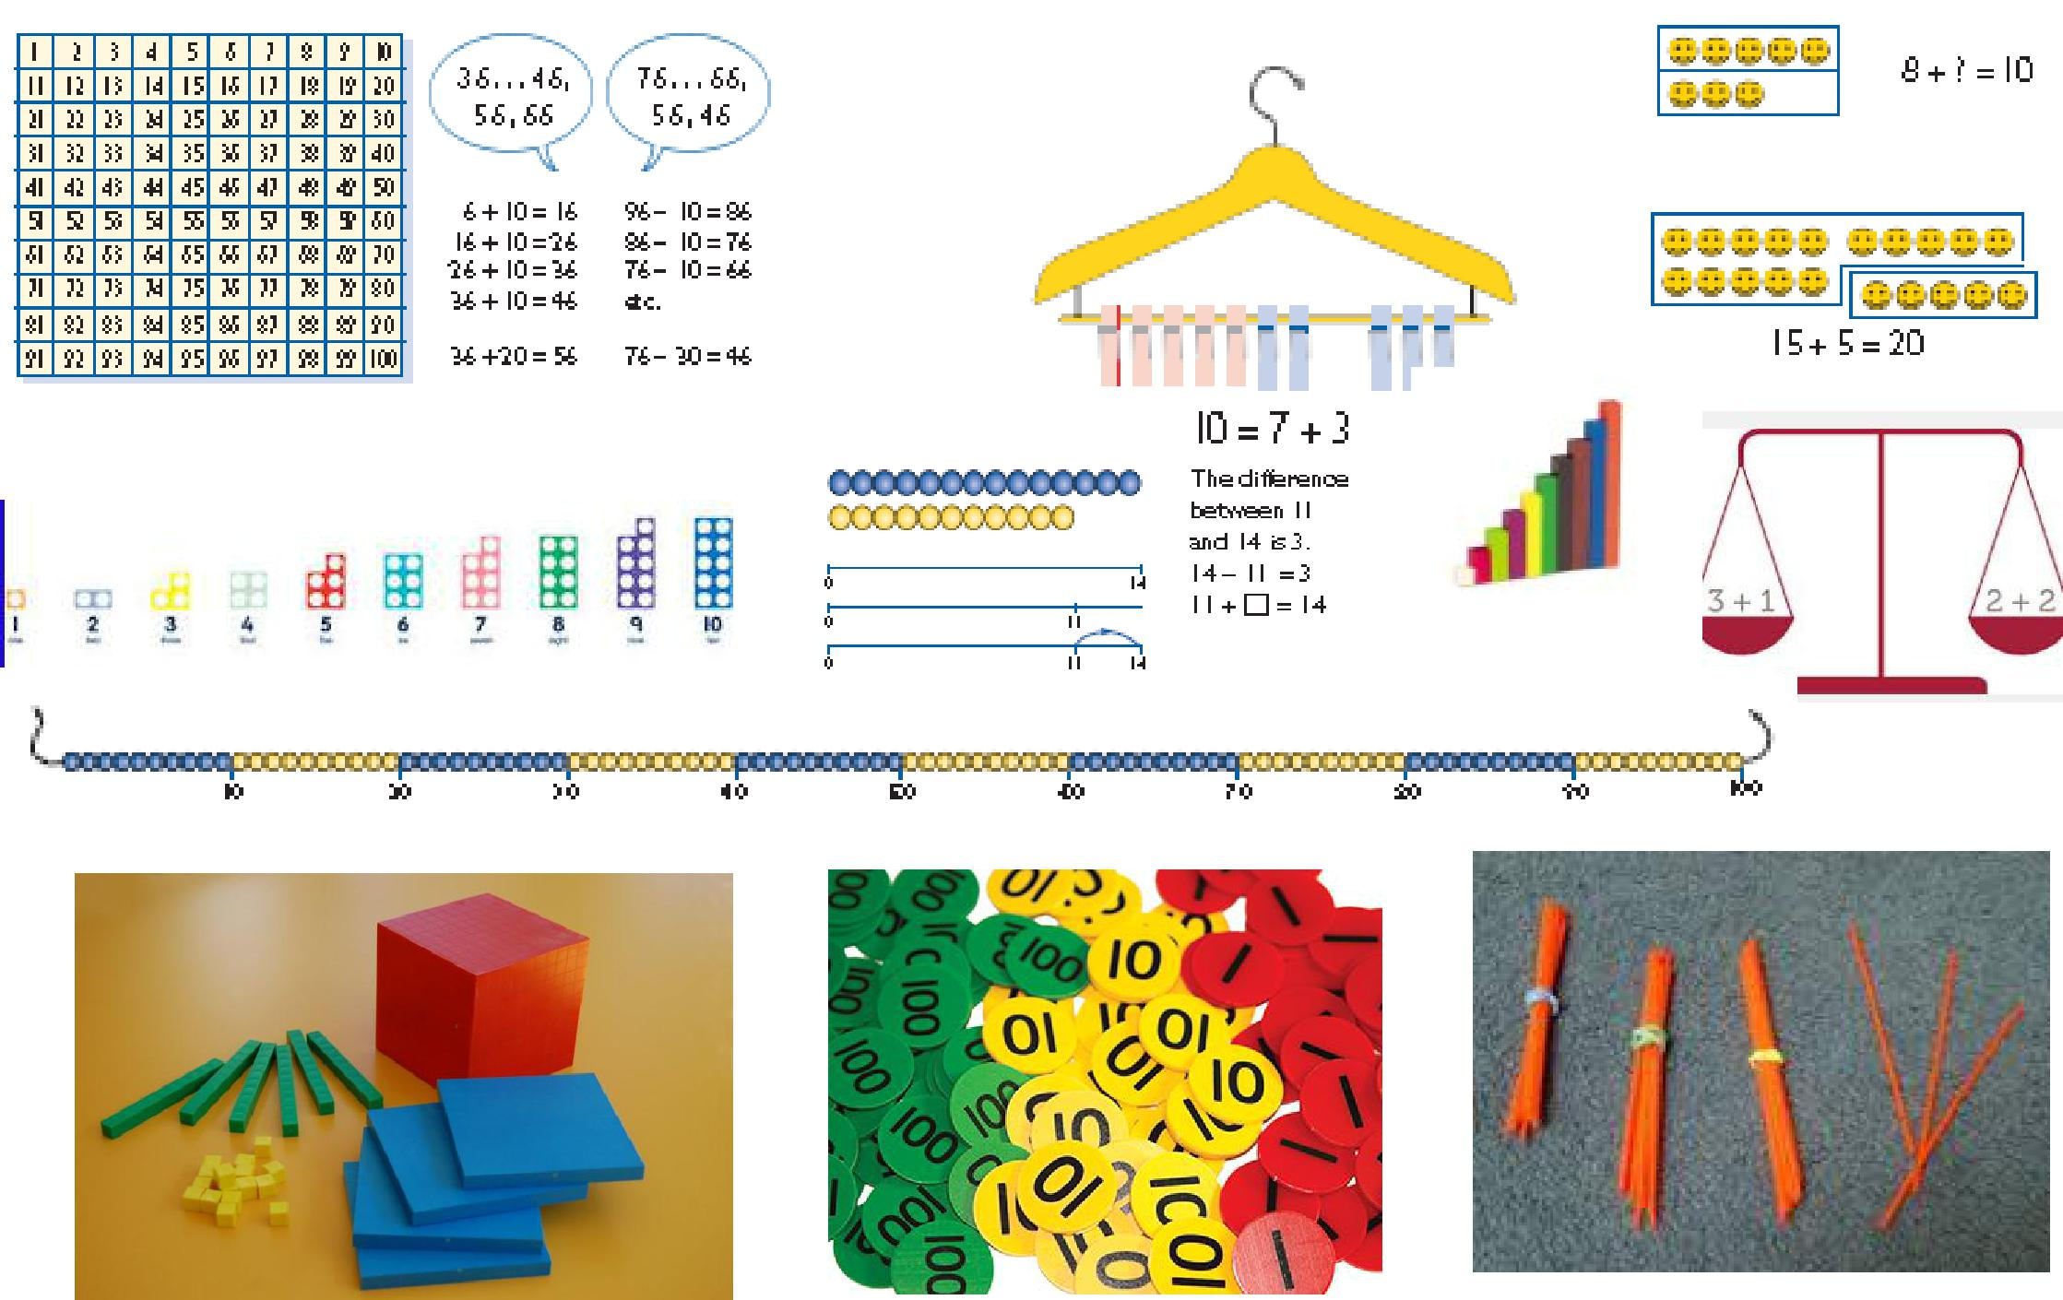
Key representations to support conceptual understanding of addition and subtraction
Year 1 Addition and Subtraction
- Read, write and interpret mathematical statements involving addition, subtraction and equals signs  - Represent and use number bonds and related subtraction facts within 20  - Add and subtract one digit and two digit numbers to 20, including zero | Using known facts  If we know 5 + 4 = 9  We also know:  4 + 5 = 9  9 – 5 = 4  9 – 4 = 5  14 + 5 = 19  19 – 4 = 15 etc. | 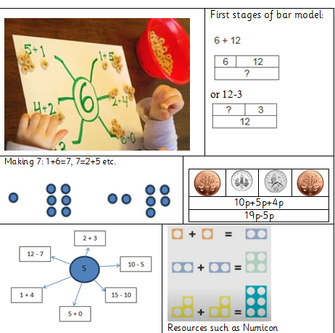  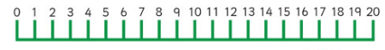
Mental Jottings with representations

Immerse children in practical opportunities to develop understanding of addition and subtraction. Link practical representations on a number track on a bead string to recording on a number line. By the end of Year 1 children should be able to recall and use facts within and to 20.

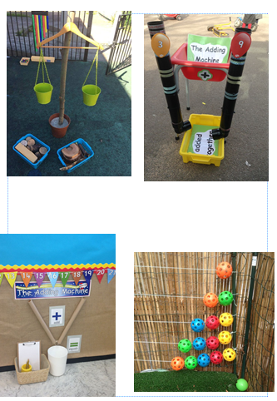 | 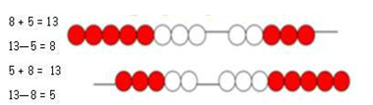  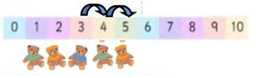

Year 2 Addition and subtraction
Show that addition of two  numbers can be done in any order and subtraction cannot.  Recall and use addition and  subtraction facts to 20 fluently  derive and use related facts up to 100.  Add and subtract numbers using concrete objects, pictorial presentations and mentally including:  2-digit number and ones  2-digit number and tens  Two 2 digit numbers  Add three 1 digit numbers  Solve problems with addition and subtraction:  using concrete objects and  pictorial representations,  including those involving  numbers, quantities and  measures applying their increasing knowledge of mental and written methods |  | Using known facts  Fluency to 20  Practise in as many ways as possible  Bridge through 10  26 + 7 = 26 + 4 + 3  26 + 4 = 30  30 + 3 = 33  Counting on/back in10s  26 + 20 =  67-20  Partitioning  23 + 34 = 20+30+3+4  Use bonds to 10  2 + 7 + 8 = 8 + 2 + 7  Finding the difference between two numbers. 71 – 37  Use a number line to count on from smallest to largest number.  Partitioning numbers in different ways in preparation for  subtracting using decomposition:  90 + 2  80 + 12 (I have subtracted a ten and added it onto the ones)  Continue to record mental jottings as outlined in Year 2 with  increasingly larger numbers.  Use suitable resources as required  Children that have not achieved the age related expectations for Year 2 should not move onto formal written methods until they are secure with mental recall/jottings.
  If I know:  2+3 = 5 | I also know:  3+2 = 5  20 + 30 = 50  30 + 20 = 50  50—30 = 20  50—20 = 30
  Using a place value chart
  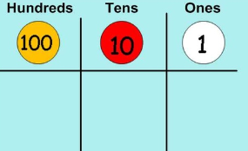
  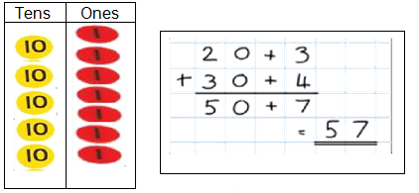
  15 + 15 + 15 = 30+15
  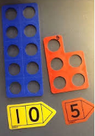
  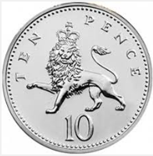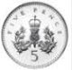
  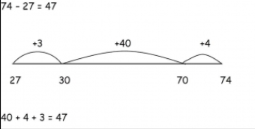
Examples of strategies for addition:  - 35+36 (near doubles + 1)  - 36 + 49 (near multiples of 10: 36 + 50 -1)  - 75 + 8 (bridging through 10: 75+5+3)  - 38+27 (partitioning 30+20+8+6) |  |  | Examples of strategies for subtraction:  - 54 - 5 (bridging through 10: 54 – 4 – 1)  - 46 - 19 (subtracting near multiples of 10: 36 -20 + 1)  - 50 – 25 (known number facts, doubles and halves)  - 53 – 22 (partitioning 53 – 20 - 2)
Year 3 Addition and Subtraction
Add and subtract numbers mentally  - A 3-digit number and 1s  - A 3-digit number and 10s  - A 3-digit number and 100s  - Add and subtract numbers with up to 3 digits using formal written methods of columnar addition and subtraction.  - estimate the answer to a calculation  - use inverse operations to check answers  - solve problems, including missing number problems, using number facts, place value, and more complex addition | Towards written methods:  - Use expanded column addition to add two or three digit numbers or three two digit numbers  - Begin to use compact column addition to add numbers with three digits  - Begin to add non unit fractions (1/8 + 3/8 + 2/8)  Towards fluency:  - Use place value and number facts to add a single digit to a two-digit number and explain answer  - Add or subtract mentally combinations of one-digit and two-digit numbers  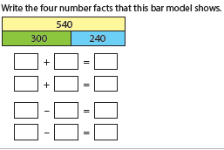 |  |  | Written methods
  256 + 145  (including regrouping)  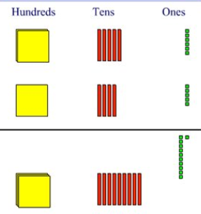 |  | 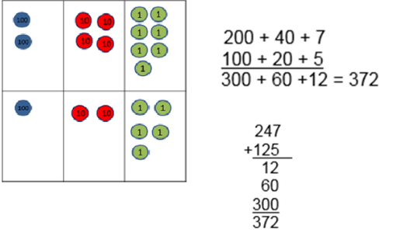
  Expanded method leading to formal subtraction (including regrouping)
  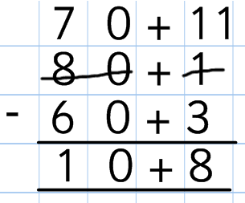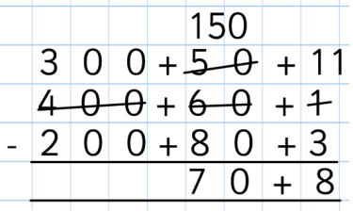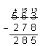
  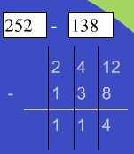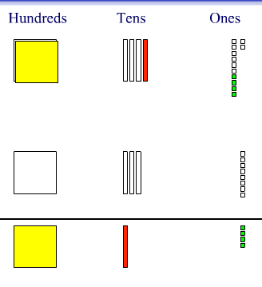
  *SEE APPENDIX FOR STAGES OF WRITTEN METHODS FOR ADDITION AND SUBTRACTION
  Use a place value chart | 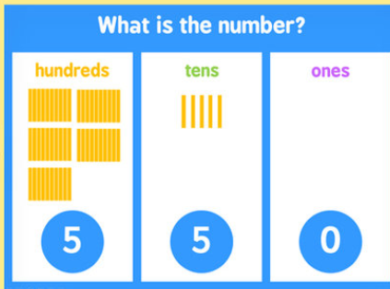  Dienes apparatus |  | 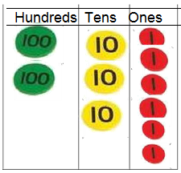Place value disks

Year 4
- Continue to secure and extend mental methods from previous year groups.  - To select whether a calculation can be done mentally, with a jotting or using a formal written method.  - Add and subtract numbs with up to 4 digits using formal written methods of column addition and subtraction where appropriate. | Develop confidence at calculating mentally with larger numbers.  Use the full range of strategies:  - Counting in 1s / 10s  - Bridging through multiples of 10  - Partitioning  - Rounding and adjusting  - Reordering  - Near doubles  - Calculating with time  - solve addition and subtraction two-step problems in contexts, deciding which operations and methods to use and why. | Written methods *SEE APPENDIX FOR STAGES OF WRITTEN METHODS FOR ADDITION AND SUBTRACTION
  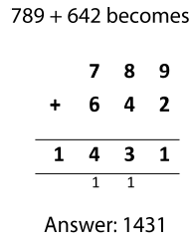 | 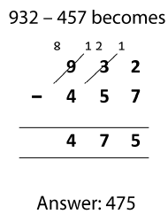
  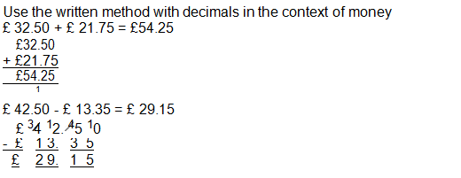
  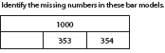

Year 5
- Add and subtract whole numbers with more than 4 digits, including formal written methods (columnar addition and subtraction)  - Add and subtract numbers mentally with increasingly large numbers  - Use rounding to check answers to calculations and determine, in the context of a problem, levels of accuracy  - Solve addition and subtraction multi-step problems in contexts, deciding which operations and methods to use and why | Use knowledge of place value to calculate mentally with increasingly larger numbers.  Employ a range of special strategies to develop confidence in calculating mentally e.g.:  2364 + 1999 =  2364 + 2000 = 4364  4364 - 1 = 4363  Or  13484 + 2400 =  13000 + 2000 = 15000  484 + 400 = 884  15000 + 884 = 15884 | Written methods *SEE APPENDIX FOR STAGES OF WRITTEN METHODS FOR ADDITION AND SUBTRACTION
  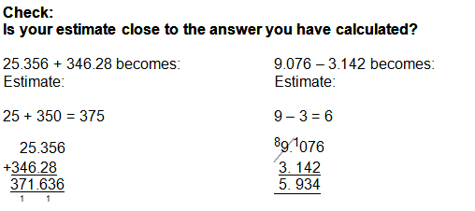
  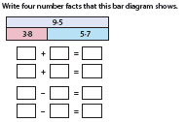

Year 6 Addition and Subtraction
- Perform mental calculations, including with mixed operations and large numbers  - Use their knowledge of order of operations to carry out calculations involving the four operations  - Solve addition and subtraction multi-step problems in contexts, deciding which operations and methods they should use and why | Ensure children use a wide range of mental strategies when calculating including decimals and increasingly larger numbers  What is 2 minus 0.005?  What is 5.7 added to 8.3?  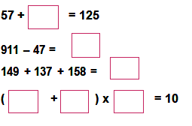 | Written methods *SEE APPENDIX FOR STAGES OF WRITTEN METHODS FOR ADDITION AND SUBTRACTION
  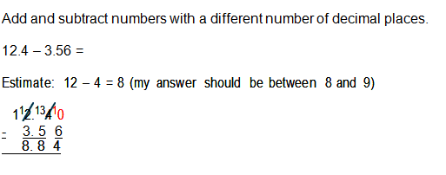
  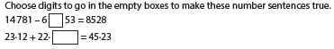

Year 1 Multiplication and Division
- Count, read and write numbers to 100 in numerals; count in multiples of twos, fives and tens  - Double numbers to 20 | - Use of visual models to support counting in 2, 5, 10  - Ensure children begin to see the patterns of counting in 2, 5, 10.  - Double/halve numbers up to:  - 10 + 10 = 10 x 2  - 20 – 10 = 20 ÷ 2 | Models and Images to support Multiplication (see also stages of division)  You have 4 apples, and I have 4 apples.  How many apples do we have altogether?  4 + 4 makes 8  Double 4 = 8  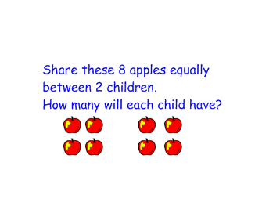  Each pot has 10 pencil.  Count in tens.  How many althogether?  10 plus 10 plus 10 plus 10 = 40  4 lots of 10  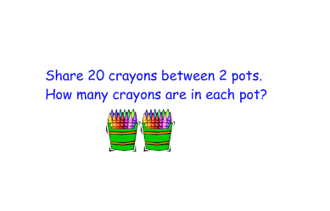  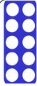  There are six pairs of socks.  How many socks altogher?  Count in 2s.  2, 4, 6, 8, 10, 12 6 lots of 2  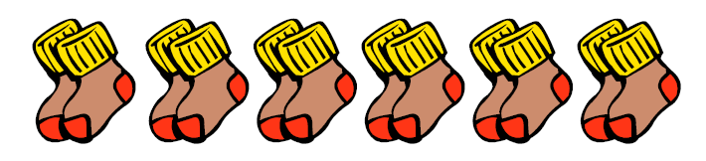

Year 2 Multiplication and Division
- count in steps of 2, 3, and 5  from 0, and in tens from any  number, forward or backward  - recall and use multiplication and division facts for the 2, 5 and 10 multiplication tables,  - including recognising od and even numbers  - show that multiplication of two numbers can be done in any order (commutative) and division of one number by another cannot  - calculate mathematical statements for multiplication and division within the multiplication tables and write them using the multiplication (×), division (÷) and equals (=) signs | - 2 x 5 = 10  - 5 x 2 = 10  - 10 ÷ 2 = 5  - 10 ÷ 5 = 2  - Use knowledge of doubling:  - 2 x 10 = 20  - 10 x 2 = 20  - 20 ÷ 2 = 10  - 20 ÷ 10 = 2  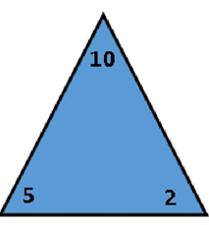  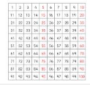 | Models and Images to support Multiplication (see also by stages of division)
 |  | Each pot has 10 pencil.  Count in tens.  How many althogether?  10 plus 10 plus 10 plus 10 = 40  4 lots of 10 | 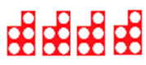  How many altogether?  5 + 5 + 5 + 5  4 lots of 5
 |  | Use arrays to discuss multiplication.  2 lots of 5  5 lots of 2  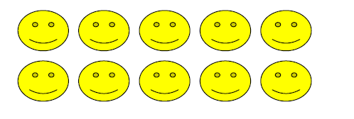 | 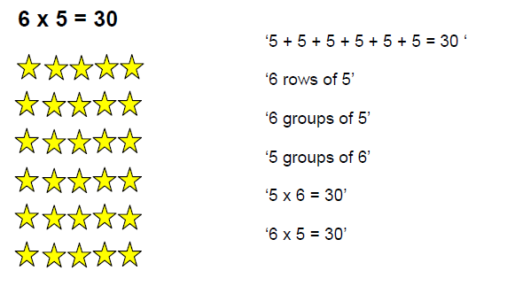
 |  | Jump in steps of 5.  1 lot of 5 = 5 1 x 5 = 5  2 lots of 5 = 10 2 x 5 = 10  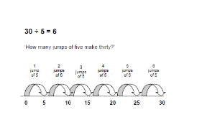 | 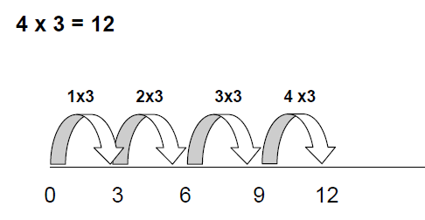

Year 3 Multiplication and Division
- count from 0 in multiples of 4, 8, 50 and 100  - multiplication and division facts for the 3, 4 and 8 multiplication tables  write and calculate mathematical statements for multiplication and division using the multiplication tables that they know,  - including for two-digit numbers times one- digit numbers, using mental and progressing to formal written methods | Models and Images to support Multiplication (see also stages of division)
 | 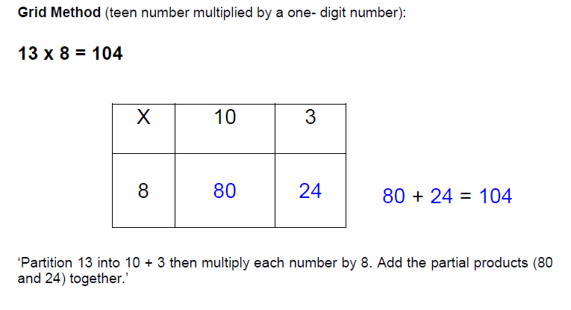 | 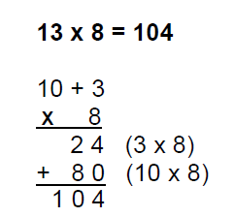
 | 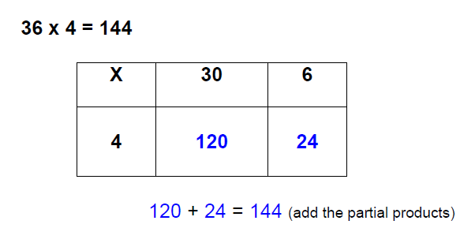 | 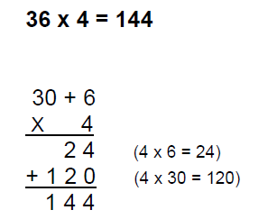

Year 4 Multiplication and Division
- count in multiples of 6, 7, 9, 25 and 1 000  - recall multiplication and division facts for multiplication tables up to 12 × 12  - use place value, known and derived facts to multiply and divide mentally, including:  - multiplying by 0 and 1;  - dividing by 1;  - multiplying together three numbers. Recognise and use factor pairs and commutativity in mental calculations  - multiply two-digit and three-digit numbers by a one-digit number using formal written layout | Models and Images to support Multiplication (see also by stages of Division)
 | 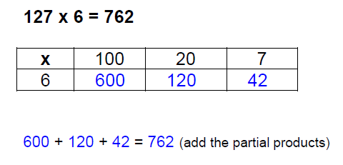 |  | 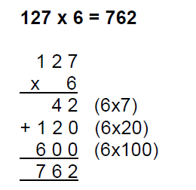
 | 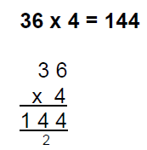  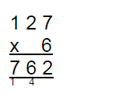 | 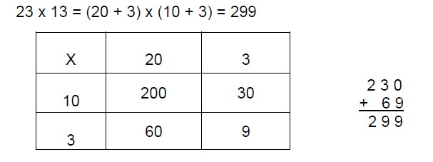

Year 5 Multiplication and Division
- count forwards or backwards in steps of powers of 10 for any given number up to 1 000 000  - multiply and divide numbers mentally drawing upon known facts  - multiply and divide whole numbers and those involving decimals by 10, 100 and 1000 identify multiples and factors, including finding all factor pairs of a number, and common factors of two numbers.  - know and use the vocabulary of prime numbers, prime factors and composite (non- prime) numbers  - establish whether a number up to 100 is prime and recall prime numbers up to 19 recognise and use square numbers and cube numbers, and the notation for squared (2) and cubed (3)  - multiply numbers up to 4 digit by a one- or two-digit number using a formal written method, including long multiplication for two-digit numbers  - divide numbers up to 4 digits by a one-digit number using the formal written method of short division and interpret remainders appropriately for the context | Models and Images to support Multiplication (see also by stages of Division)
 | Expanded Long Multiplication:  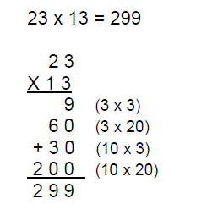 | Compact Long Multiplication:  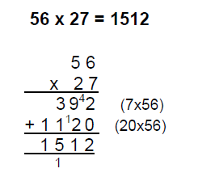
 | 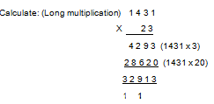

Year 6 Multiplication and Division
- perform mental calculations, including with mixed operations and large numbers  - identify common factors, common multiples and prime numbers  - Use their knowledge of the order of operations to carry out calculations involving the four operations | Models and Images to support Multiplication (see also by stages of Division)
 | 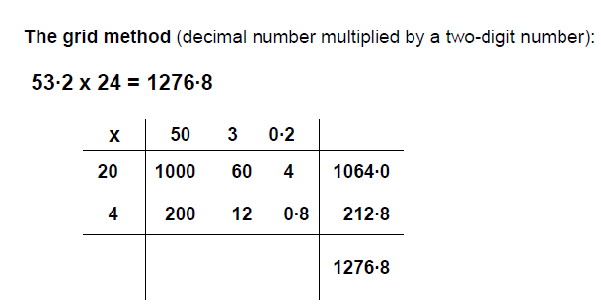
 | 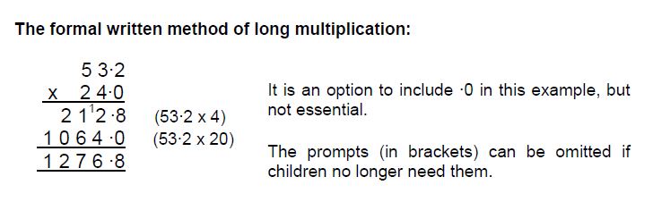

Stages of division with models and images
1. | 2.
3.  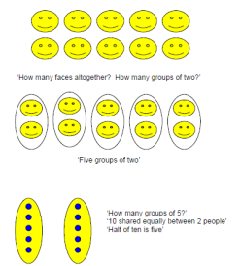 | 4  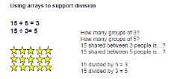
 | 5. | 20 ÷ 5 = 4.  How many 5s in 20?

Stages of division with models and images
6. |  |  |  | 30 ÷ 5 = 6  How many jumps of five make thirty? | 7.  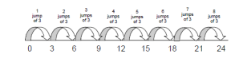 |  |  | 24 ÷ 3 = 8  How many 3s in 24?
8.  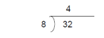 | 32 ÷ 8 = 4  Use the formal written method, using multiplication tables that they know.  How many 8s are in 32? |  |  |  | 9.  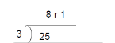 |  | 25 ÷ 3 = 8 r 1
10.  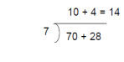 |  | Partition 98 into 70 + 28.  There are 10 sevens in 70 and 4 sevens in 28.  10 + 4 = 14 |  |  | 11.  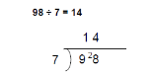
12.  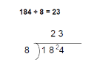 |  |  |  |  | 13  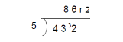 | 432 ÷ 5 = 86 r 2
14.  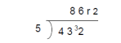 |  |  | The remainder can also be expressed as a fraction:  432 ÷ 5 = 86

Stages of division with models and images
15. Formal method, long division
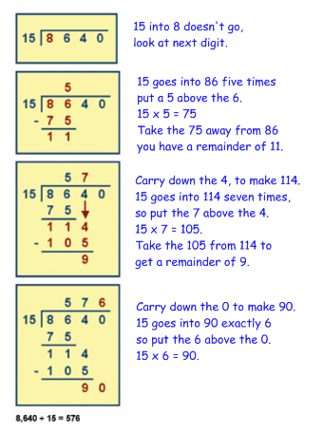

Fractions: Year 2 Objectives:
• Recognise, find, name and write fractions 1/3, ¼, 2/4 and ¾ of a length, shape, set of objects or quantity.
• Write simple fractions, e.g. ½ of 6 = 3 and recognise the equivalence of 2/4 and ½.
Part of a whole  (item or quantity, or set of items) | Result of division | Fraction of a number | Ratio  (one object is a fraction of another)
- Find 1/3, ¼, 2/4, ¾ of shapes, groups of items and continuous quantities, e.g. lengths, sand and water.  - Complete the shading on this diagram so that one half is shaded: | Say half of every whole number up to 20.  • What fraction of the dots has a ring around them? | Count in halves up to 10, showing this on a number line and visually, e.g. as halves of a rectangular model. | Make a tower 1/3 or 3/4 of the size of this one.
 |  |  | 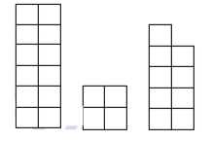
-  | 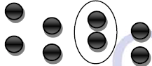 | 
- Solve problems such as finding 1/2 of numbers as groups of items, first practically then recorded as number sentences.  - Show that 2/4 = ½, 3/3 = 1 practically to understand a whole group / item split into fractions. | Share 1, 2, 3 or 4 things such as pizzas, and chocolate bars between 3 and then 4 people to solve problems.  • Use equal grouping and sharing to find unit fractions.  • Plan a picnic and explore dividing different sorts of food and drinks between people using equal sharing and grouping.  • Test statements to confirm whether they are always, sometimes, never true: “There are 4 numbers less than 10 that divide exactly in half to give a whole number.”  • Word problems: “Think of a number and then halve it. The answer is 9. What could the number be?” | Count in quarters up to 10 showing this on a number line and visually. (Use fact that 2/4 = ½ when counting in quarters.)  • Fold card / string / ribbon into thirds or quarters.
Make the tower ½ as tall.
o Make the tower twice / half as wide.
• Make and talk about patterns for example with beads or multilink such as:
o Using 20 cubes, make a shape that is ½ red and ¼ blue. What fraction is left?
o In an array for 12, ½ of the cubes are blue, ¼ are red and the rest are green. How many are there of each colour? If there were 10 identical arrays, how many cubes of each colour would there be?

- On a clock face, show ¼ to/past the hour. How far round the clock face is ¾ of the hour?  - Use time and a clock face to support understanding of ½ and ¼ by solving problems such as: “Mary went into a shop at 10:30 and came out at 10:45. What fraction of the hour was she in the shop?”  - PE lesson: turn ½, ¼, ¾ turns clockwise and anti-clockwise.  - Program robots to travel around a maze.  - Understand a right angle as a quarter-turn.  - Use two geo-strips to make and draw half and quarter turns from the same starting point.  - Describe what is happening in repeating patterns: |  | Use / create a fraction wall with halves, thirds and quarters. Link to the number line.
 |  | 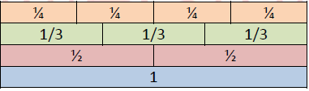
Position ½ s and ¼ s on a numberline

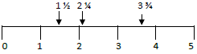



Fractions: Year 3 Objectives:
• Count up and down in tenths; recognise that tenths arise from dividing an object into 10 equal parts and in dividing one-digit numbers or quantities.
• Recognise, find and write fractions of a discrete set of objects: unit fractions and non-unit fractions with small denominators.
• Recognise and use fractions as numbers: unit fractions and non-unit fractions with small denominators.
• Recognise and show, using diagrams, equivalent fractions with small denominators.
• Add and subtract fractions with the same denominator within one whole [e.g. 5/7 + 1/7 = 6/7].
• Compare and order unit fractions and fractions with the same denominator.
• Solve problems that involve all of the above.
Part of a whole  (item or quantity, or set of items) |  |  | Result of division |  | Fraction of a number |  | Ratio  (one object is a fraction of another)
Show a unit fraction of any denominator of a whole shape, set of objects, and continuous quantity to solve problems.  o What fraction of the jug is full? How much water is in it? |  | Use division to compare and order unit fractions (e.g. of pieces of string) to solve problems.  o Find ½, ¼, 1/10 of 1 metre, kilometre, kilogram ....  • Divide pieces of string or strips of paper to order fractions of the same denominator.  • Understand the equivalence of finding ½ and dividing by 2 where the faction is used as an |  | Count in unit and non-unit fractions, forwards and backwards, showing this visually with for example a rectangular model and on a number line. |  | Link to multiplication: scaling e.g. A bar is four times as long or a quarter of the length.  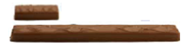
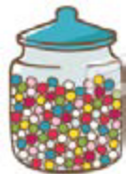 | .  A jar holds 100 sweets when it is full. Some have been eaten. About how many are left?
 |  |  |  | 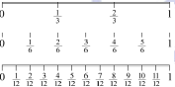
 |  |  |  |  |  | 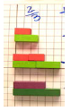 |  | Compare two small Cuisenaire rods and say what fraction one rod is of the other another.
Show any non-unit fractions with small denominator of sets of objects and shapes and quantities. Link this to division problems.
• Use shapes such as a rectangular model to order unit fractions and non-unit fractions with the same denominator.
Take 20 cubes. Make a shape which is ½ red and 1/10 blue.
• Solve simple ratio problems:
o A pink roll of tape is 50cm long. A yellow one is ½ as long. How long are they altogether?
o Two cakes are shared equally between six people. How much each?

 |  |  |  | Make fraction walls to show equivalence on squared paper or with Cuisenaire rods. Start with families of fractions with small denominators (e.g. eighths, quarters, halves).
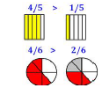
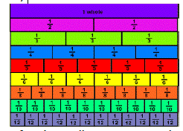
Use a fraction wall to compare and order fractions with the same denominator.

Part of a whole  (item or quantity, or set of items) |  | Result of division | Fraction of a number | Ratio  (one object is a fraction of another)
Show fractions on a rectangular model and use this to add and subtract fractions with the same denominator within one whole. |  | Use division to compare and order unit fractions (e.g. of pieces of string) to solve problems.  o Find ½, ¼, 1/10 of 1 metre, kilometre, kilogram ....  • Divide pieces of string or strips of paper to order fractions of the same denominator.  • Understand the equivalence of finding ½ and dividing by 2 where the faction is used as an | Use a fraction wall to support ordering fractions on a number line.  Show fractions on a number line starting with unit fractions up to and beyond 1. | 12 sweets are shared equally between 4 children; how much each?  o William has made a pattern using 12 tiles. One tile in every four is red. How many tiles are red?  o The distance to the park is ¼km. If I went and came back every day of the week. How far will I have travelled?  o To get to school, it takes 1 hour. To get back home takes ¾ of the time. How long will it take to get back home?  o The width of a pond is 1/3 of its length. If it is 6m long, how wide is it?
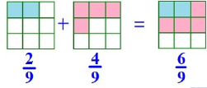
 |  |  | 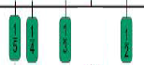
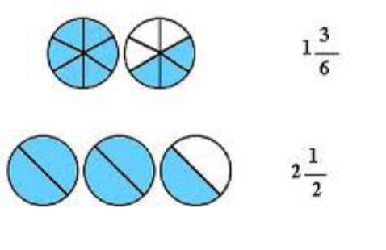 | Explore mixed numbers in practical contexts e.g. 1 ½ cakes
 | Explore mixed numbers in practical contexts e.g. 1 ½ cakes |  | Choose a number on a number line – where would ½, ¼, 1/5 of this be?  • What number is ½ way between:  o 3 and 4?  o 2½ and 3? Etc.  • Relate positioning fractions on a number line to measures problems (e.g. of length in m and cm).
Understanding that quarter turns are right angles. Recognise that two right angles total a ½-turn and three right angles total a ¾ turn.

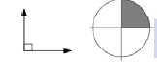

Understanding of compass points and the link to ¼, ½, ¾ turns to face different directions. Link to using directional vocabulary both clockwise and anti-clockwise.


 |  |  | 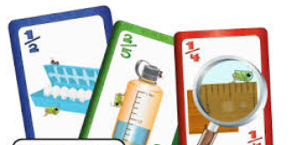

Fractions: Year 4 Objectives:
• Recognise and show, using diagrams, families of common equivalent fractions.
• Count up and down in hundredths; recognise that hundredths arise when dividing an object by one hundred and dividing tenths by ten.
• Solve problems involving increasingly harder fractions to calculate quantities, and fractions to divide quantities, including non-unit fractions where the answer is a whole number.
• Add and subtract fractions with the same denominator.
• Solve simple measure and money problems involving fractions.
Part of a whole  (item or quantity, or set of items) | Result of division | Fraction of a number | Ratio  (one object is a fraction of another)
Find non-unit fractions of a number where the answer is a whole number.  E.g. Find 2/3 of 12 = 4.  • Find any fraction of a number practically and then recording as a number sentence. Include find tenths and hundredths of numbers.  • Show any fraction of measures, shapes, or sets of items to solve problems, e.g.:  o A bottle of lemonade holds approximately ¼l or 1¼l?  o There are 36 children in a class. Half of them have flavoured crisps. One third of them have plain crisps. How many children have crisps?  o Gran gave me £8 of my £10 birthday money. What fraction of my birthday money did Gran give me?  • Use a rectangular model marking it with horizontal lines to show a fraction and show equivalent fractions by splitting the rectangle up into smaller fractions with horizontal lines.  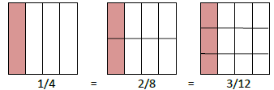 | Understand a fraction as an operator, particularly for 1/10 (as ÷ 10) and 1/100 (as ÷ 100).  • Link division to showing tenths as fractions and decimals.  • Divide measures, shapes and sets of objects to show any fraction and solve problems.  o What is 1/10, 1/5, 1/4 of £1?  o What is 1/10, 1/5, 1/4 of 100g? | Draw or make fraction walls with squared paper or Cuisenaire rods. Use this to identify families of common equivalent fractions. | Link to multiplication scaling problems.  o Three cakes to be shared between nine people. Everyone then gets 1/3 of a cake.  o For every black square there are 2 white in a pattern. In 20 squares, how many squares will be black?
 |  | 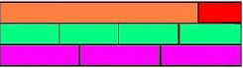
Link fractions to the number line and measurement, and then to factors and multiples to support the understanding of equivalent fractions.
Use factors and multiples to recognise and simplify equivalent fractions.
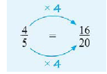
To cook rice, you need 5 cups of water for every cup of rice. In the saucepan, you put in 3 cups of rice. How much water needs to go in the mix?
o A potato weighs about ¼kg. Roughly how much do 10 potatoes weigh? How many times heavier is a 1kg potato?
• Compare any two Cuisenaire rods and say what fraction one rod is of the other another. (E.g. 4/6 of the total is yellow, 2/6 of the total is red.)

Part of a whole  (item or quantity, or set of items) |  | Result of division | Fraction of a number | Ratio  (one object is a fraction of another)
Show mixed numbers practically and with a rectangular model:  e.g. 4/3 = 1 1/3  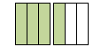  Use a rectangular model to add and subtract fractions with the same denominator, using fractions with larger denominators and beyond 1.  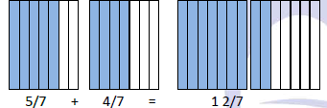 |  |  | Link fractions to place value. E.g. Show tenths and hundredths as fractions and decimals.  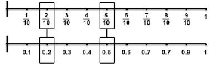 | Comparison of two quantities and use of these to solve problems:  o What fraction of the larger bag of flour is the smaller bag?
Use the bar model to support the solving of word problems:
o Ben has a third as many sweets as Bill. If Ben has 8 sweets, how many marbles do they have altogether?
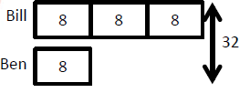
Show that ten hundredths makes a tenth.
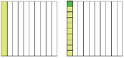

Show tenths and hundredths on a number line and when measuring. (E.g. 1/10 of a metre is 10cm.)
• Use number lines to make connections between any fraction and measures: mark fractions on a number line.
• Count in fractions including tenths and hundredths, forwards and backwards. E.g. counting on in tenths from 3.5:
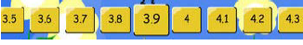
Equate the eight  compass directions to  eighths of a complete  turn and use this to turn.  E.g. Starting at N, then  turn 3/8 of the way  around. What way are  you now facing? | 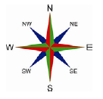

Fractions: Year 5 Objectives:
• Compare and order fractions whose denominators are all multiples of the same number.
• Identify, name and write equivalent fractions of a given fraction, represented visually, including tenths and hundredths.
• Recognise mixed numbers and improper fractions and convert from one form to the other and write mathematical statements > 1 as a mixed number (e.g. 2/5 + 2/5 = 6/5 = 1 1/5).
• Add and subtract fractions with the same denominator and denominators that are multiples of the same number.
• Multiply proper fractions and mixed numbers by whole numbers, supported by materials and diagrams.
• Read and write decimal numbers as fractions (e.g. 0.71 = 71/100)
• Recognise and use thousandths and relate them to tenths, hundredths and decimal equivalents.

Part of a whole  (item or quantity, or set of items) | Result of division | Fraction of a number | Ratio  (one object is a fraction of another)
Represent mixed numbers, e.g. using a rectangular model and convert to improper fractions and record formally.  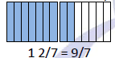  Use a rectangular model to identify and name and write equivalent fractions by splitting the rectangle into small fractions. Link to factors and multiples.  Compare and order fractions by using a rectangular model where denominators are all multiples of the same number. | Express remainders resulting from division as a fraction  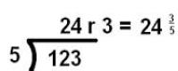  Convert between fractions and decimals including thousandths.  • Explore which fractions simplify to whole numbers and which do not, recording as mixed numbers and improper fractions  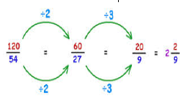 | Draw or make fraction walls with squared paper or Cuisenaire rods. Use this to compare fractions and show families of any equivalent fractions; decide which rod or length of whole to start with to show families of fractions. Link to factors and multiples.  E.g. decide to use a 12 rod or length to show thirds and twelfths. (The pairs of factors of 12 are 3 and 4, 2 and 6.)  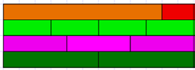  Link fraction walls to the number line and measurement scales and place fractions on the line to order them  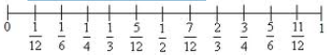  Link to measurements such as scales on tape measures and dial scales. | Link to scaling in multiplication, i.e. scaling by a fraction:  o If the length of a child’s foot is 1/3 of the size of an adults and the adult’s foot is 48cm, how long is the child’s foot?  o This is the list of ingredients to make 20 gingerbread biscuits. If I wanted to make only 5, how much of each ingredient would I need?  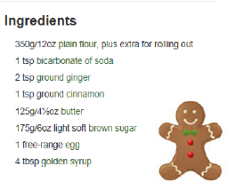

Part of a whole  (item or quantity, or set of items) | Result of division | Fraction of a number | Ratio  (one object is a fraction of another)
Add and subtract fractions with the same denominator, or denominators that are multiples of the same number.  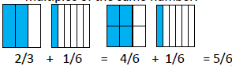  Add and subtract fractions with the same denominator and denominators which are multiples of the same number using a rectangular model, totalling over 1.  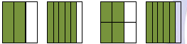  Using a rectangular model multiply proper fractions and mixed numbers by whole numbers. (Link this to scaling.)  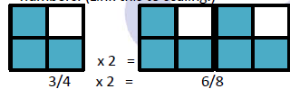  Solve problems involving fractions:  o Estimate a record halves, quarters or tenths of 1km, 1kg, 1l ... .  o I work for 8 hours and sleep for 10 hours. What fraction of the day do I work / sleep?  o What fraction of 1km is 250m? | Solve problems involving fractions such as:  o Which would you rather win? 1/100 of £1,000,000 or 2/10 of £100,000?  o Put three mars bars on one chair, two on another one on another. Take it in turns to stand behind the chair with the most mars bars but you must share them equally with the people already standing there. | Link mixed numbers to the number line.  • Count in mixed numbers and in fractions, forwards and backwards, including bridging zero.  E.g. Counting up in quarters from -¼.  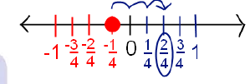  Make connections between fractions and percentages:  e.g. finding 1/100 = 1%; 50/100 = 50%; 25/100 = 25%. | Solve problems with ratio:  o Cut up a piece of rope in the ratio of 1:6.  o At the gym, there are 2 boys for every 3 girls. There were 15 girls at the gym, how many boys were there? There were 35 people altogether, how many girls were there?  o A mother seal is fed 5 fish for every 2 fish for its baby. If the mother seal is fed 15 fish, how many fish are used altogether?  • Use the bar model to support the solving of problems:  o The total prize money from a competition is £80. John and Toby share the prize money. John receives ¾ of the money. How much does Toby receive?  

